**DAILY ONLINE ACTIVITIES SUMMARY**

|  |  |  |  |  |  |  |  |  |
| --- | --- | --- | --- | --- | --- | --- | --- | --- |
| **Date:** | **22-07-2020** | | | | | **Name:** | **Kanaka BS** | |
| **Sem & Sec** | **6th & A** | | | | | **USN:** | **4al17cs039** | |
| **Online Test Summary** | | | | | | | | |
| **Subject** | | **CGV IA Module 3** | | | | | | |
| **Max. Marks** | | **30** | | **Score** | | | **-** | |
| **Certification Course Summary** | | | | | | | | |
| **Course** | **Python for Data Structures** | | | | | | | |
| **Certificate Provider** | | | **Coursera** | | **Duration** | | | **19 hours** |
| **Coding Challenges** | | | | | | | | |
| **Problem Statement**: **Python Program for Check if count of divisors is even or odd** | | | | | | | | |
| **Status: Solved** | | | | | | | | |
| **Uploaded the report in Github** | | | | | **yes** | | | |
| **If yes Repository name** | | | | | <https://github.com/kanakabs/Daily-Status> | | | |
| **Uploaded the report in slack** | | | | | **yes** | | | |

**ONLINE COURSE**

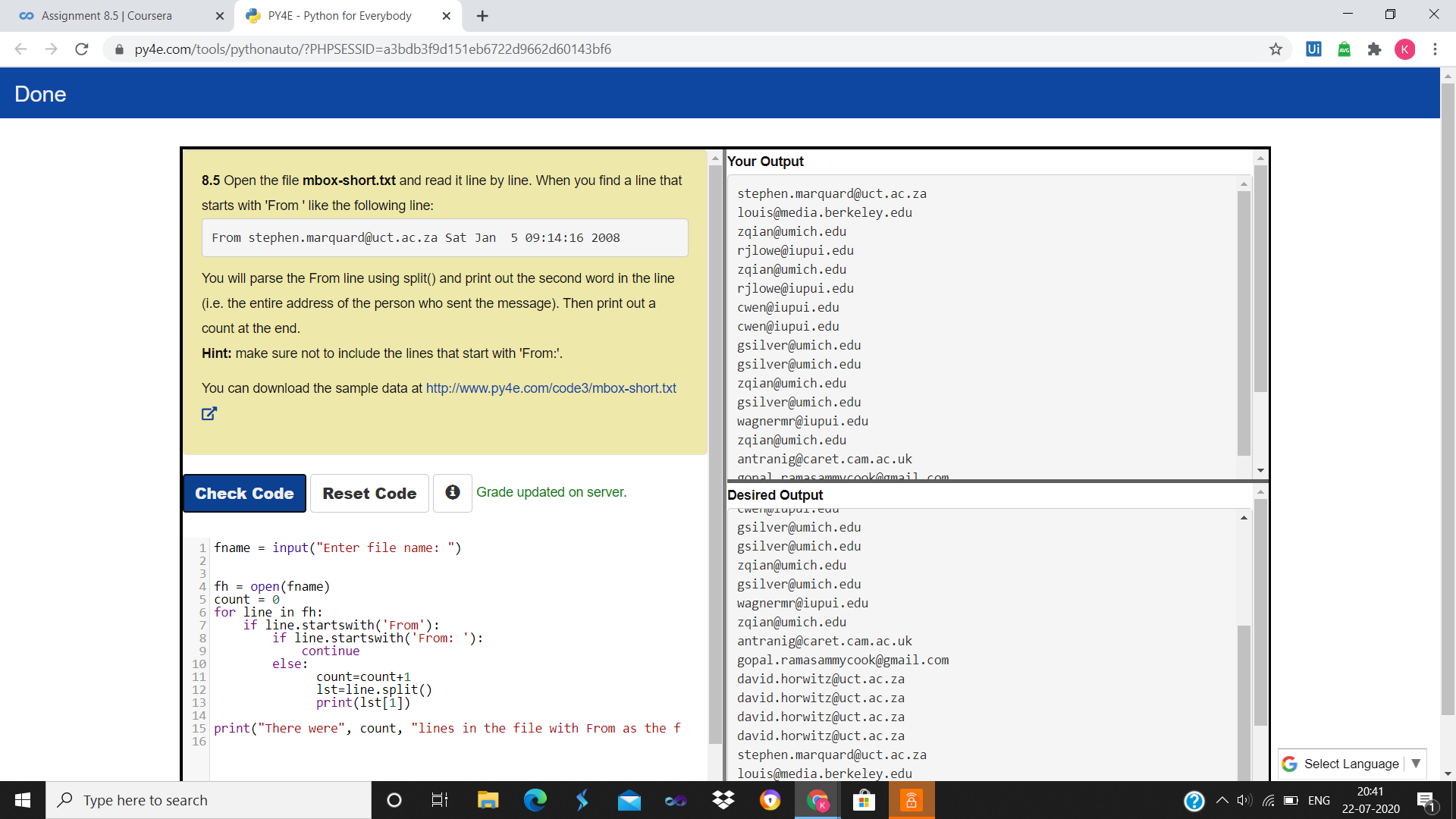

**ONLINE** **CODING**

**Python Program for Check if count of divisors is even or odd**

def NumOfDivisor(n):

if n < 1:

return

root_n = n**0.5

if root_n**2 == n:

print("Odd")

else:

print("Even")

if __name__ == '__main__':

print("The count of divisor of 12 is: ")

NumOfDivisor(12)

